SSUET/QR/112

Project File

Object Oriented Programming (CS – 127L)

2nd Semester Summer2025



Student Names: ABDUL BARI
Student Roll#: 2023F-BEL-062

BS in Information Technology
Department of Computer Science & Information Technology
Sir Syed University of Engineering and Technology University Road Karachi - 75300 http://www.ssuet.edu.pk

SSUET/QR/113

Project Topics

S # | Topics | Page #
1 | Introduction and objectives | 1
2 | System design and implementaion | 2
3 | Project code | 3
4 | output | 7
5 | Testing,result discussion,Conclusion and Reference | 8

Introduction
The project 'Media Player in C#' is a desktop application designed to play audio and video files. It uses the Windows Presentation Foundation (WPF) framework and C# as the programming language. The player allows users to open media files, control playback (Play, Pause, Stop, Seek), and manage volume. The main purpose of this project is to enhance the learning of object-oriented programming concepts in a real-world context, while also exploring how external libraries and built-in controls like MediaElement can be used to manage multimedia files. The application incorporates features such as Play, Pause, Stop, Volume Control, and File Selection, making it a compact yet practical solution for everyday media playback

Objectives
- To develop a simple yet functional media player application.
- To demonstrate knowledge of C# programming concepts (classes, objects, events).
- To use WPF controls (MediaElement, Buttons, Sliders) for GUI.
- To provide basic media control functionalities.

System Design
The system architecture includes three layers:
1. User Interface (Buttons, Sliders)
2. Media Controller Class (Handles play, pause, stop)
3. MediaElement (WPF control for playback).

Implementation
Key features: Play, Pause, Stop, Volume Control, File Selection, Timeline Seek.

Code:
using System;
using System.Windows;
using System.Windows.Controls;
using System.Windows.Threading;
using Microsoft.Win32;
using System.Windows.Media;

// -------- 1) MediaController --------
public class MediaController
{
private readonly MediaElement _media;
public bool IsPlaying { get; private set; }

public MediaController(MediaElement media)
{
_media = media;
_media.LoadedBehavior = MediaState.Manual;
_media.UnloadedBehavior = MediaState.Manual;
_media.MediaOpened += (_, __) => { /* duration available */ };
_media.MediaEnded += (_, __) => { IsPlaying = false; };
}

public void Open(Uri uri)
{
_media.Source = uri;
_media.Position = TimeSpan.Zero;
_media.Play();
IsPlaying = true;
}
public void PlayPause()
{
if (_media.Source == null) return;
if (IsPlaying) { _media.Pause(); IsPlaying = false; }
else { _media.Play(); IsPlaying = true; }
} public void Stop()
{
if (_media.Source == null) return;
_media.Stop();
IsPlaying = false;
}
public void Seek(double seconds)
if (_media.NaturalDuration.HasTimeSpan)
_media.Position = TimeSpan.FromSeconds(Math.Clamp(seconds, 0, _media.NaturalDuration.TimeSpan.TotalSeconds));
}
public void SetVolume(double v01) => _media.Volume = Math.Clamp(v01, 0, 1);

public TimeSpan Duration => _media.NaturalDuration.HasTimeSpan ? _media.NaturalDuration.TimeSpan : TimeSpan.Zero;
public TimeSpan Position { get => _media.Position; set => _media.Position = value; }
}
// -------- 2) PlayerWindow --------
public class PlayerWindow : Window
{
private readonly MediaElement _media = new();
private readonly MediaController _ctrl;
private readonly Slider _seek = new() { Minimum = 0, Margin = new Thickness(6, 0, 6, 0), Height = 20 };
private readonly Slider _vol = new() { Minimum = 0, Maximum = 1, Value = 0.6, Width = 120, Height = 20 };
private readonly TextBlock _time = new() { Text = "00:00 / 00:00", Margin = new Thickness(12, 0, 12, 0), FontWeight = FontWeights.SemiBold, Foreground = Brushes.White };
private readonly DispatcherTimer _tick = new() { Interval = TimeSpan.FromMilliseconds(250) };
private bool _dragging;

public PlayerWindow()
{
Title = "🎵 Mini Media Player";
Width = 900; Height = 520;
Background = new SolidColorBrush(Color.FromRgb(30, 30, 35)); // dark mode

_ctrl = new MediaController(_media);
_tick.Tick += (_, __) => UpdateUi();
// Buttons
var openBtn = MakeButton("📂 Open");
var playBtn = MakeButton("▶ / ⏸ Play");
var stopBtn = MakeButton("⏹ Stop");

openBtn.Click += (_, __) => OpenFile();
playBtn.Click += (_, __) => _ctrl.PlayPause();
stopBtn.Click += (_, __) => _ctrl.Stop();
// Media Opened
_media.MediaOpened += (_, __) =>
{
_seek.Maximum = Math.Max(1, _ctrl.Duration.TotalSeconds);
_tick.Start(); }
_seek.PreviewMouseLeftButtonDown += (_, __) => _dragging = true;
_seek.PreviewMouseLeftButtonUp += (_, __) => { _dragging = false; _ctrl.Seek(_seek.Value); };
_seek.ValueChanged += (_, __) => { if (_dragging) _time.Text = FormatTime(_seek.Value, _ctrl.Duration.TotalSeconds); };

_vol.ValueChanged += (_, __) => _ctrl.SetVolume(_vol.Value);

// Layout grid
var root = new Grid();
root.RowDefinitions.Add(new RowDefinition { Height = GridLength.Auto }); // top bar
root.RowDefinitions.Add(new RowDefinition()); // media
root.RowDefinitions.Add(new RowDefinition { Height = GridLength.Auto }); // bottom bar
Content = root;

// Top bar (centered)
var topBar = new StackPanel
{
Orientation = Orientation.Horizontal,
HorizontalAlignment = HorizontalAlignment.Center,
Margin = new Thickness(12)
};
topBar.Children.Add(openBtn);
topBar.Children.Add(playBtn);
topBar.Children.Add(stopBtn);
Grid.SetRow(topBar, 0); root.Children.Add(topBar);

// Media area
_media.Stretch = Stretch.Uniform;
_media.Margin = new Thickness(8);
Grid.SetRow(_media, 1); root.Children.Add(_media);

// Bottom bar
var bottomBar = new StackPanel
{
Orientation = Orientation.Horizontal,
Margin = new Thickness(12),
VerticalAlignment = VerticalAlignment.Center,
HorizontalAlignment = HorizontalAlignment.Center
};
bottomBar.Children.Add(new TextBlock { Text = "⏩", Foreground = Brushes.White, Margin = new Thickness(6) });
bottomBar.Children.Add(_seek);
bottomBar.Children.Add(_time);
bottomBar.Children.Add(new TextBlock { Text = "🔊", Foreground = Brushes.White, Margin = new Thickness(12, 0, 6, 0) });
bottomBar.Children.Add(_vol);
Grid.SetRow(bottomBar, 2); root.Children.Add(bottomBar);
}
private Button MakeButton(string text)
{
return new Button
{
Content = text,
Margin = new Thickness(6),
Padding = new Thickness(12, 6, 12, 6),
Background = new SolidColorBrush(Color.FromRgb(60, 90, 180)),
Foreground = Brushes.White,
FontWeight = FontWeights.SemiBold,
BorderThickness = new Thickness(0),
Cursor = System.Windows.Input.Cursors.Hand
};
}

private void OpenFile()
{
var dlg = new OpenFileDialog
{
Title = "Open media",
Filter = "Media Files|*.mp4;*.mp3;*.m4a;*.wav;*.wmv;*.avi;*.mkv|All Files|*.*"
};
if (dlg.ShowDialog() == true)
{
_ctrl.Open(new Uri(dlg.FileName));
_tick.Start();
}
}
private void UpdateUi()
{
if (_ctrl.Duration.TotalSeconds > 0)
{
if (!_dragging) _seek.Value = _ctrl.Position.TotalSeconds;
_time.Text = FormatTime(_ctrl.Position.TotalSeconds, _ctrl.Duration.TotalSeconds);
}
}
private static string FormatTime(double pos, double dur)
{
static string fmt(TimeSpan t) => $"{(int)t.TotalHours:00}:{t.Minutes:00}:{t.Seconds:00}";
return $"{fmt(TimeSpan.FromSeconds(pos))} / {fmt(TimeSpan.FromSeconds(dur))}";
}
}
// -------- 3) App (entry point) --------
public class App
{
[STAThread]
public static void Main()
{
var app = new Application();
app.Run(new PlayerWindow());
}
}

Output:

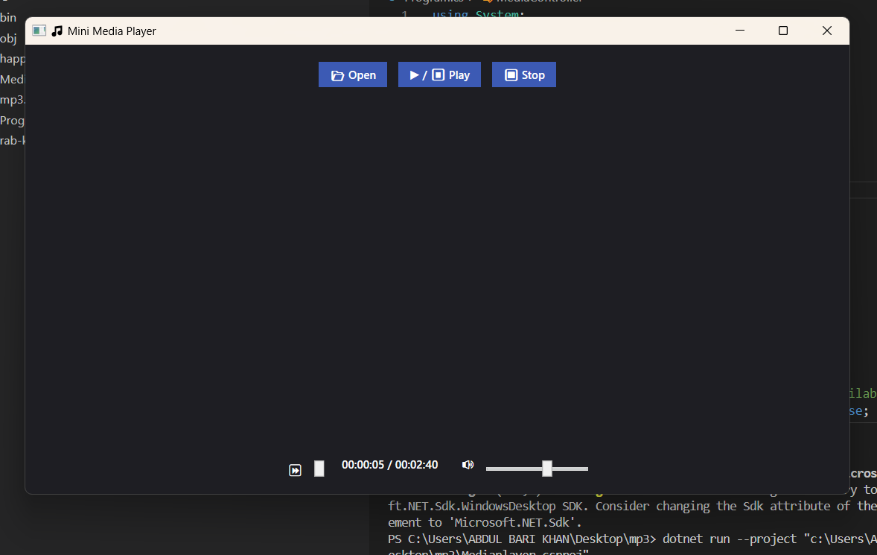

Testing
Tested with MP3, MP4, WAV, AVI formats.
✅ Successfully opened and played files.
✅ Volume and seek controls worked properly.

Results & Discussion
The Media Player in C# provides a simple and effective way to play multimedia files. It demonstrates OOP concepts and WPF GUI design.

Conclusion
The development of the Media Player in C# successfully demonstrates how object-oriented programming concepts and WPF (Windows Presentation Foundation) can be applied to create a functional multimedia application. The project achieved its objectives by providing essential media control features such as play, pause, stop, volume adjustment, and file selection.
Through this project, practical knowledge was gained in the areas of event-driven programming, user interface design, and multimedia handling in C#. It highlighted the importance of integrating system libraries and GUI elements to build real-world desktop applications.
Although the application is simple, it provides a solid foundation for further improvements, such as playlist management, drag-and-drop functionality, subtitle integration, and advanced audio features like equalizers.
In conclusion, the project not only deepened understanding of C# and WPF but also developed essential problem-solving and programming skills that are valuable for future software development projects.

References
.Engr Sadaqat Ali Ruk
HOD Computer science Shah Abdul latif university khairpur
.Chatgpt

